**ARDUINO PROGRAMMING**

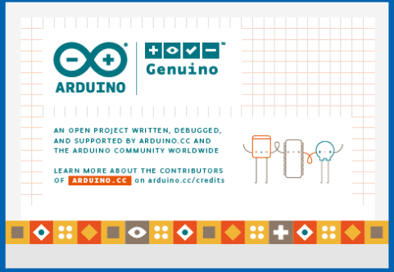

Arduino is an open-source electronics platform based on easy-to-use hardware and software. [Arduino boards](https://www.arduino.cc/en/Main/Products) are able to read inputs - light on a sensor, a finger on a button, or a Twitter message - and turn it into an output - activating a motor, turning on an LED, publishing something online. You can tell your board what to do by sending a set of instructions to the microcontroller on the board. To do so you use the [Arduino programming language](https://www.arduino.cc/en/Reference/HomePage) (based on [Wiring](http://wiring.org.co/)), and [the Arduino Software (IDE)](https://www.arduino.cc/en/Main/Software), based on [Processing](https://processing.org/).

Its simple and accessible user experience, Arduino has been used in thousands of different projects and applications. The Arduino software is easy-to-use for beginners, yet flexible enough for advanced users. It runs on Mac, Windows, and Linux. Teachers and students use it to build low cost scientific instruments, to prove chemistry and physics principles, or to get started with programming and robotics. Designers and architects build interactive prototypes, musicians and artists use it for installations and to experiment with new musical instruments.

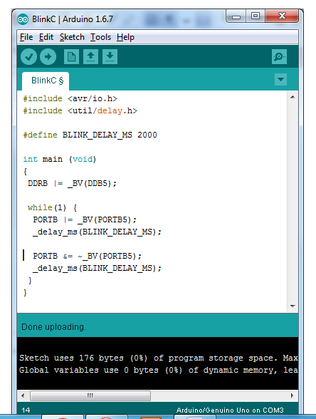

Arduino also simplifies the process of working with microcontrollers, but it offers some advantage for teachers, students, and interested amateurs over other systems:

* **Inexpensive** - Arduino boards are relatively inexpensive compared to other microcontroller platforms.
* **Cross-platform** - The Arduino Software (IDE) runs on Windows, Macintosh OSX, and Linux operating systems. Most microcontroller systems are limited to Windows.
* **Simple, clear programming environment** - The Arduino Software (IDE) is easy-to-use for beginners, yet flexible enough for advanced users to take advantage of as well.
* **Open source and extensible software** - The Arduino software is published as open source tools, available for extension by experienced programmers. The language can be expanded through C++ libraries, and people wanting to understand the technical details can make the leap from Arduino to the AVR C programming language on which it's based.